**Task1:** **Create Git hub account and a repo**

Done

**Task2: Create a file and it to git repo**

**Task3: Create a test file 1 and 2 and try to push file1 to the repo**

**Git push**

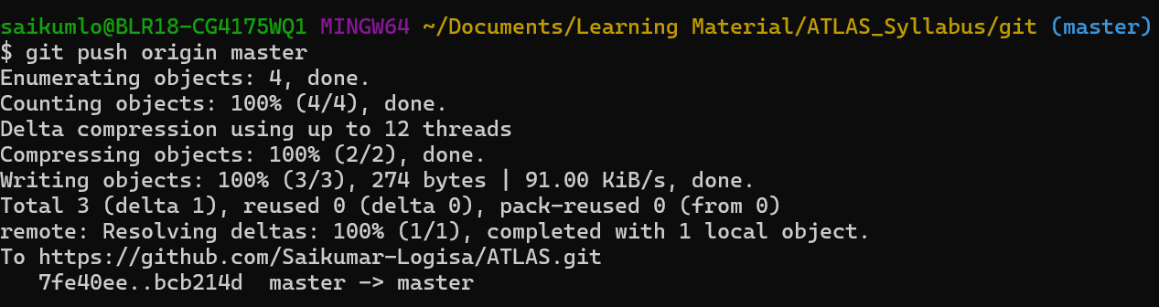

**Git show, branch**

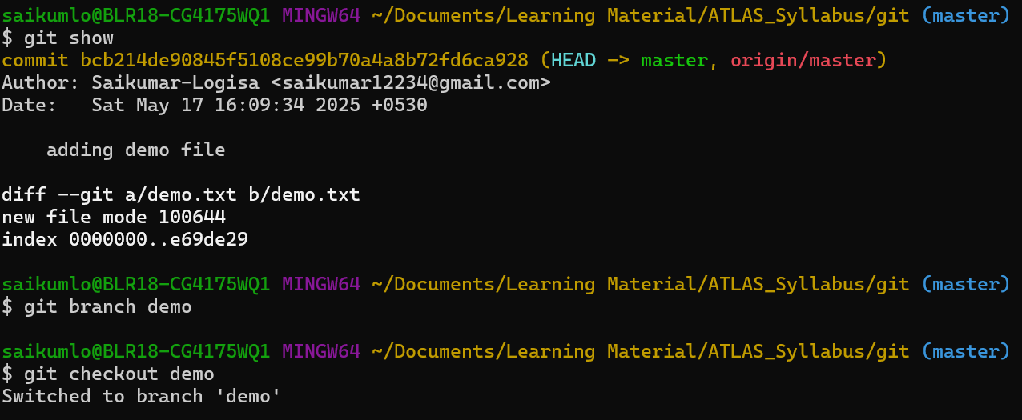

**Git log  
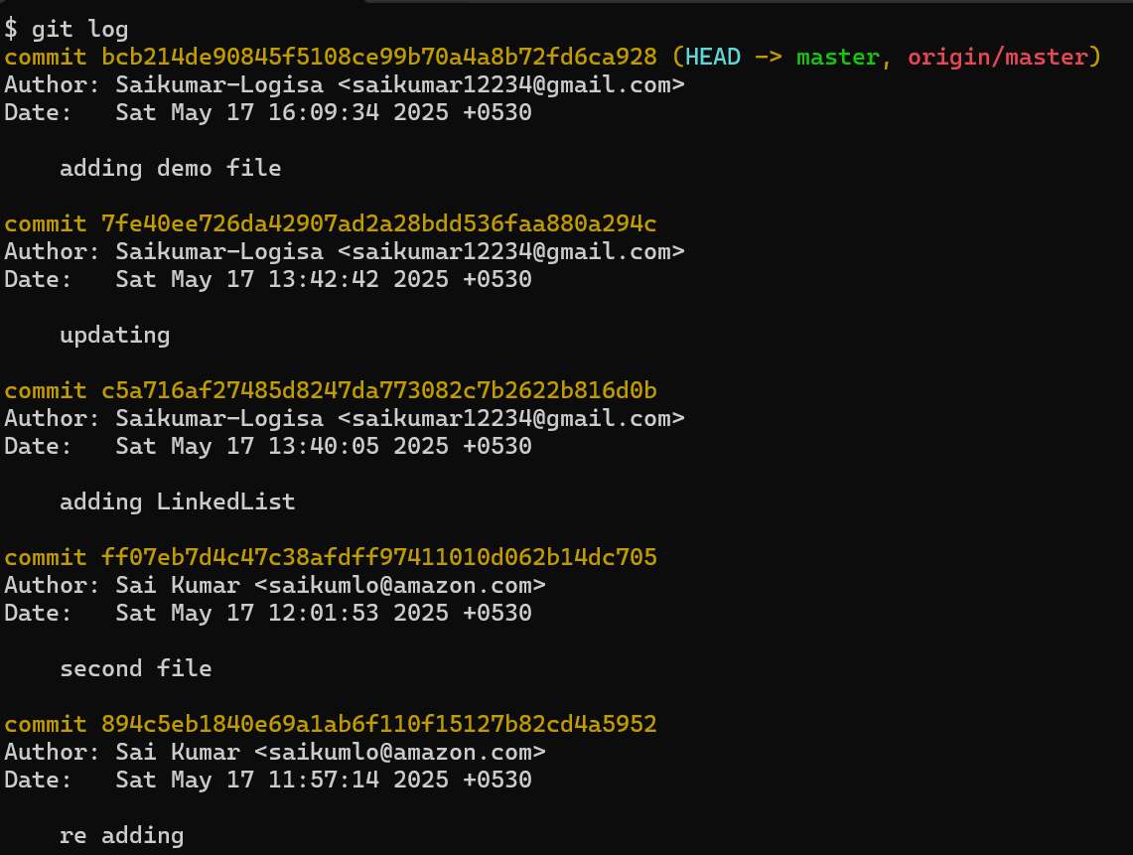**

**Git checkout & merge**

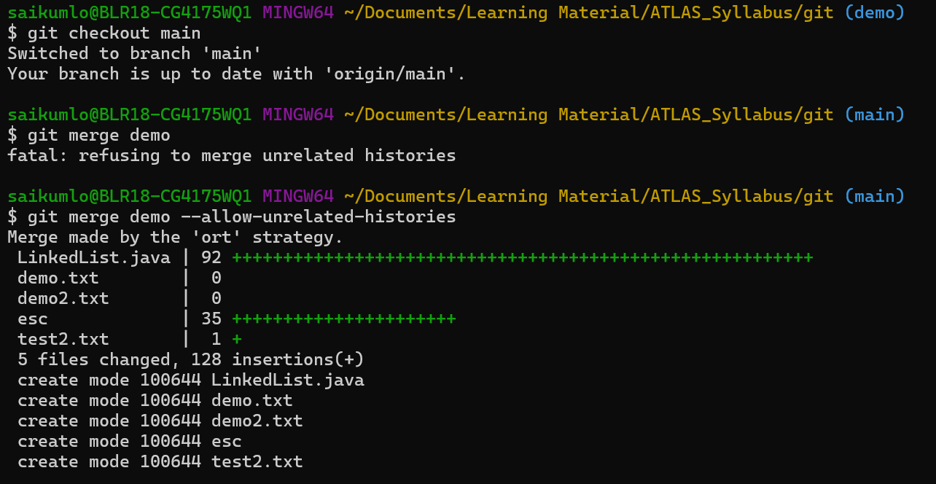

**Git restore**

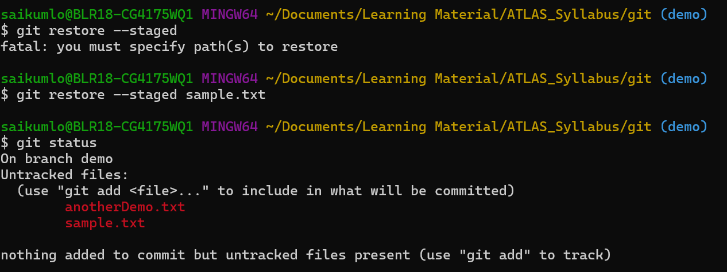

**Git stash**

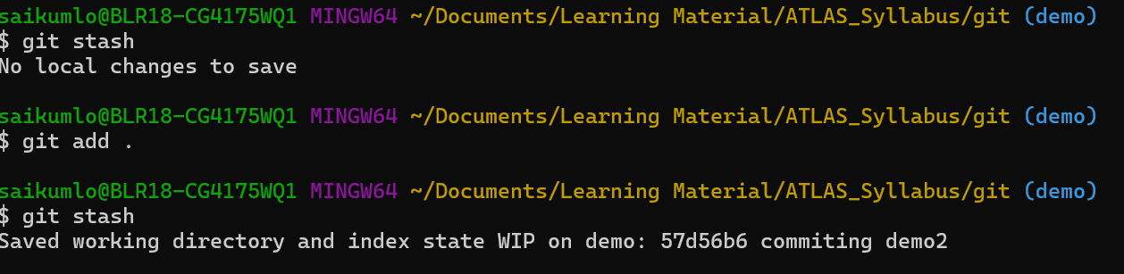

**Git reset**

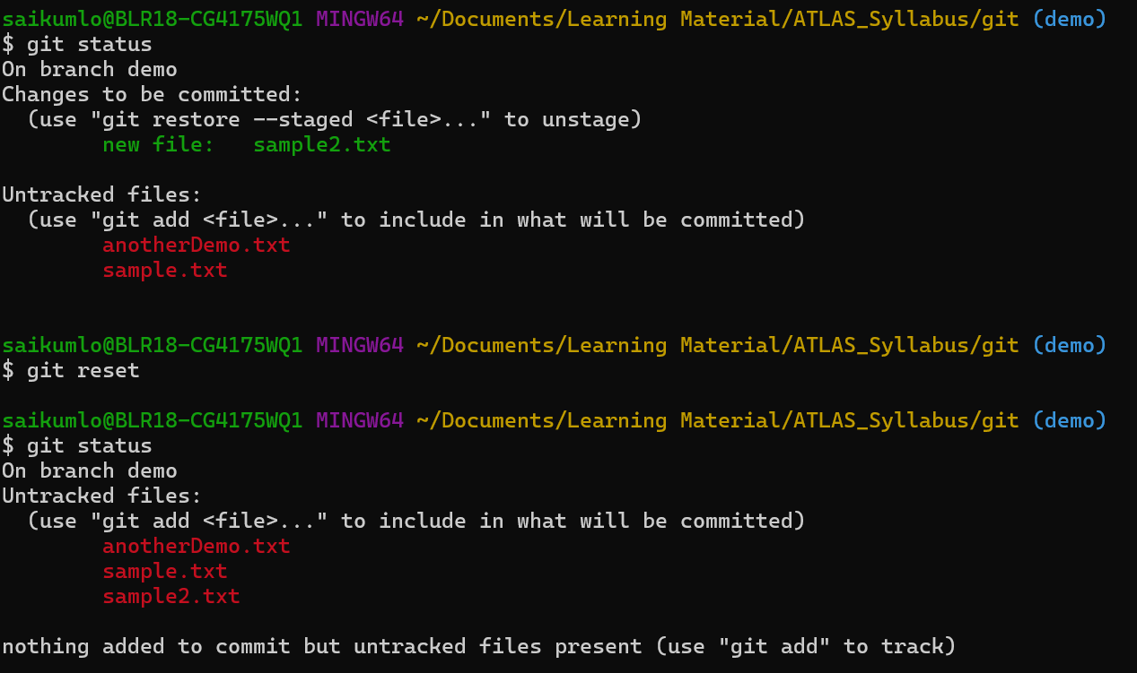

**Git revert**

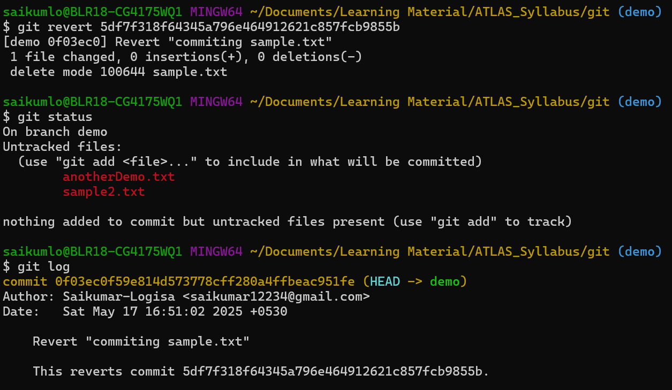

**Git clean**

